The Golden Ring of Russia
The name “Golden Ring” designates a chain of ancient medieval towns lying to the northeast of Moscow that includes some of the oldest and most beautiful settlements in all Russia dating from the X-XV centuries. Discover the glorious origins of Russia visiting the centres of religious and politic power that made the history of the Rus’ during the 12th and 13th centuries, before the birth of the Grand Duchy of Moscow. The Golden Ring cities tours will guide you through multiple UNESCO World Heritage Sites where you will have the chance to admire some of eastern Europe’s most remarkable monastery complexes, see the uniquely shaped masonry churches and the mighty fortifications of the kremlins and enjoy the relaxed atmosphere of these quiet suburbs and the beautiful Russian countryside. We offer a vast array of options for Golden Ring cities tours, from 2,3 or 4-day up to 10-day comprehensive guided tours including full Moscow and St Petersburg visit programs.
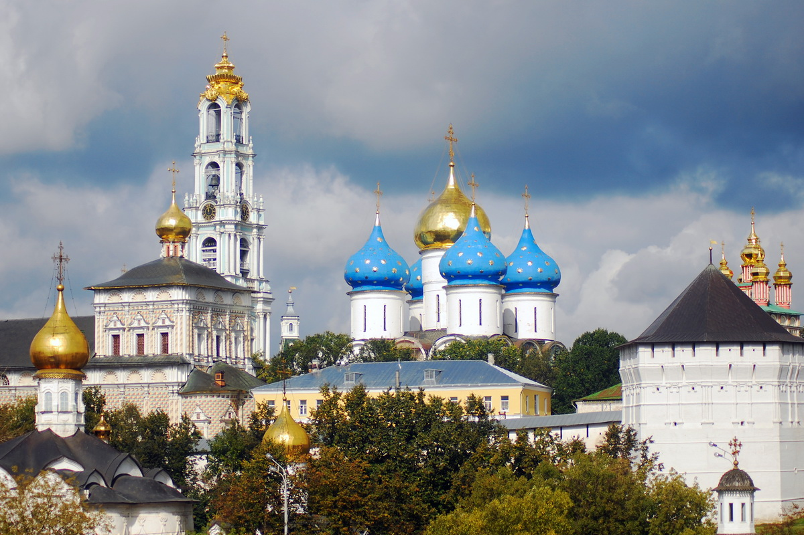

The Heart of Russia: Golden Ring cities, Moscow and St Petersburg group tour
Golden Ring cities, Moscow and St Petersburg group tours are made up of travelers from many different cities or countries who join together to experience a journey through Russia’s most iconic locations enjoying special group rates: discover the marvels of Russia and make new friends traveling for an affordable price! Guaranteed departures for groups of 4 or more traveling from any one city, the package holiday includes accommodation in Moscow and St Petersburg for 7 nights in 4* central hotels, accommodation in Suzdal and Yaroslavl for 2 nights in 4* central hotels, city sightseeing tours in all the included destinations and the support of an English-speaking guide for the full visit program. For detailed information on the tour’s itinerary, dates and prices please refer to the table below.
The 10-day group tour includes: Sergiev Posad - Vladimir - Suzdal - Kostroma - Yaroslavl - Rostov Veliky - Moscow - St Petersburg

Dates and prices 2018
10% discount for bookings made in 2017 (paying 30% in advance) for tours starting in 2018.

4 STARS COMFORT: Vedensky, Park Inn Nevsky, Sokos or similar in St. Petersburg; Novotel Center, Holiday Inn or similar in Moscow. In the category are included hotels that have quality standards similar to the 4 star European hotels.
4 STARS STANDARD: Dostoevsky or similar in St. Petersburg; Izmailovo Vega or similar in Moscow. In the category are included hotels that are officially 4 stars in Russia, but with standard comparable to the European 3 stars.
HOTEL IN THE CITIES OF GOLDEN RING: Suzdal - Pushkarskaya Sloboda 4 *, Heliopark 4 * or similar; Yaroslavl: Park Inn 4 * or similar. In these cities the hotels assigned are always of the same category, regardless of standard selection or comfort.
10% discount for bookings made in 2017 (paying 30% in advance) for tours starting in 2018.
Reduction for children: from 1 to 3 years 70%; from 3 to 11 years 30%

Included:
- Accommodation in Moscow: hotel DBL/twin room, 4 nights, breakfast included
- Accommodation in St Petersburg: hotel DBL/twin room, 3 nights, breakfast included
- Accommodation in Suzdal: hotel DBL/twin room, 1 night, full board
- Accommodation in Yaroslavl: hotel DBL/twin room, 1 night, full board
- High speed express train “Sapsan” one way from Moscow to St Petersburg (4 hours), 2nd class
- Transfers: Airport – hotel – train station – hotel - airport
- Moscow city tour including the Novodevichy Convent, visit to the Kremlin
- St Petersburg city tour including the Peter and Paul Fortress, Church of the Savior on Blood, visit to the Hermitage
- Private English-speaking guide for all the included excursions per itinerary
- Visa support/tourist invitation
- Entry tickets: Moscow Kremlin, Novodevichy Convent, Church of the Savior on Blood, Hermitage

Not Included:
- Over 65 travel insurance supplement: €16 per person
- Full visa service
- Half Board supplement: € 150 per person
- International airfare (included on request) Optional tours and services
The order of the included excursions may change. Because of the unstable conditions of the EUR/RUB exchange rate, the price published on this website may be subject to changes.
The Golden Ring group departures don’t match your schedule? Don’t worry, it is also possible to organize custom Golden Ring tours for groups or individuals in conjunction with any of the Moscow and St Petersburg scheduled departures! Please refer to the section below to find out more about the available itineraries.

Itinerary
DAY 1
Arrival in Moscow
Upon arrival, or driver will meet you in Moscow International Airport arrival lobby and escort you to the hotel.

DAY 2
Sergiev Posad and Vladimir city tour: the Trinity Lavra of San Sergius
Departure from Moscow to Sergiev Posad. Upon arrival you will start the visit a guided tour of the grand complex of the Trinity Lavra of St. Sergius, the most important spiritual center of the Russian Orthodox Church, and to its wonderful cathedrals. You will take lunch at a local restaurant and depart to Vladimir. The Vladimir city tour will include a stop at the impressive Golden Gate, the only remaining evidence of the city’s once magnificent fortifications; a visit to the architectural jewels of the XII-XIII centuries: the Dormition Cathedral (Assumption Cathedral), the Cathedral of St. Demetrius, the Cathedral of the Nativity Monastery; a visit to the Museum of Crystal. Transfer to Suzdal and accommodation at the hotel.

DAY 3
Suzdal and Kostroma city tours: the Suzdal Museum of Wooden Architecture
The visit to this town-museum focuses on its major symbols starting from the XI-XV centuries: the Kremlin, the Museum of Wooden Masterpieces, an open air museum of great ethno-anthropological importance from the XVIII-XIX centuries. In winter the visit to the Museum is replaced by an excursion to the Monastery of Saint Euthymius. Departure to Kostroma at 12 p.m., arrival and lunch. City excursion at 4 p.m.: a visit to the Ipatiev Monastery (Hypatian Monastery), the most important artistic monument founded between the XIII and XIV centuries, and its interior; a visit to the Trinity Cathedral. Departure to Yaroslavl, one of the most ancient towns of the Golden Ring, founded in 1010, full of churches, monasteries, and beautiful buildings in Baroque and Neoclassical styles. This ancient town is a part of the UNESCO World Cultural Heritage. Arrival in Yaroslavl and accommodation at the hotel.

DAY 4
Yaroslavl and Velikiy Rostov: the Monastery of the Transfiguration of the Saviour
Visit to the Monastery of the Transfiguration of the Savior, one of the most important monuments of the XII century, the Church of Elijah the Prophet, XVII century (in winter the visit to the church is replaced by the Museum of Icons). Departure for Velikiy Rostov at 11:30 a.m., arrival at 12:30 p.m., lunch. The city excursion starts from the Kremlin, dating from the XVII century and no doubt the most beautiful of the region, and continues with a visit to the museum where you can admire the rare and valuable collection of icons, paintings and miniatures in enamel by local artists. Departure for Moscow, arrival at 7.30 p.m., meet with the driver and transfer to the hotel. Accommodation at the hotel, overnight. Moscow is a capital and the main economic and financial center of Russia. The city was founded by Juriy Dolgorukiy in 1147. You will be surprised by its wide architectural and cultural variety.

DAY 5
Guided city tour of Moscow, visit to the Novodevichy Convent and the Kremlin Grounds
City sightseeing tour with stops in Moscow’s top locations: the Red Square, the central square of Moscow and all Russia; the Bolshoy Theatre, one of the most celebrated and famous temples of classical ballet; Tverskaya Street and Moscow’s financial district, the buzzing heart of the city life; the Boulevard Ring; the panoramic point on the Sparrow Hills, next to the famous Moscow State University (Lomonosov University); the Novodeviciy Convent, Moscow’s best known cloister dating back to the sixteenth century. Free time for lunch. In the afternoon, visit to the Kremlin (grounds and main cathedral). The Moscow Kremlin is a fortress located in the historic center of the city, on Borovickiy Hill. It is the oldest part of the city and one of the most important artistic and historical complexes in the country. Today the Kremlin is the seat of Russia’s national governmental institutions.

DAY 6
Optional Excursions: Sergiev Posad or the Arbat Street and Moscow Metro
Breakfast at the hotel. On your third day in Moscow you will have the chance to either participate in various optional guided tours or to take on Russia’s big capital by yourself, enjoying a full free day in the city. Recommended optional guided tours: visit to the Tretyakov National Gallery, Old Arbat and Moscow Metro walking tour.

DAY 7
Departure to St Petersburg
Free time in the morning. Our guide will meet you in the hotel lobby and escort you to the train station. High-speed train to St Petersburg (Sapsan, 2nd class). Upon arrival, our driver will take you to the hotel.

DAY 8
Guided city tour of St Petersburg, visit to the Peter and Paul Fortress and the Hermitage State Museum
Breakfast at the hotel. City tour of St Petersburg with stops at Saint Isaac’s square, the Church of the Savior on Blood, which was erected on the place where the Tsar Alexander II of Russia had been killed, Art Square, which owes its name to the numerous museums and theaters in the vicinity, the cruiser Aurora, which is now a floating museum, Nevsky Prospekt, the Smolny Cathedral, built and designed by Bartolomeo Rastrelli, and finally, the Field of Mars. Then a visit to the Peter and Paul Fortress, founded in 1703, where the city’s history initially began. Visit of the State Hermitage, one of the most important art collections in the world; the building was originally a part of the imperial palace, the residence of the Romanov dynasty for 2 centuries until 1917, the year of the beginning of the October Revolution. Return to the hotel.

DAY 9
Optional Excursions: the summer residences of the Tsars, Pushkin, Peterhof and Plavlosk
Breakfast at the hotel. Free day. Recommended optional excursions to the summer residences of the Tsars: Pushkin (Catherine’s Palace and the Amber room), Peterhof (with its beautiful park and fountains), Pavlovsk (palace and park of Paul I).

DAY 10
Departure from St Petersburg Breakfast at the hotel. After the check-out our driver will meet you in the lobby and take you to the airport. Departure from St Petersburg.
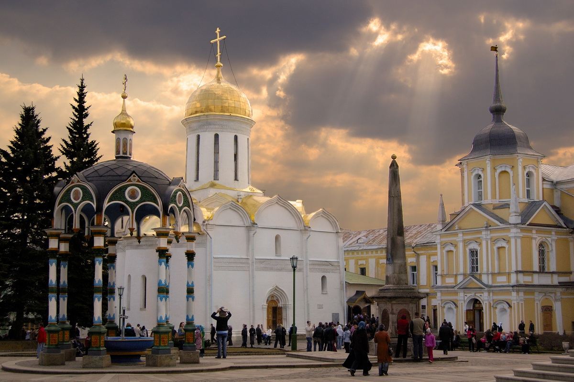

2, 3 and 4-day Golden Ring tours
Join us in a unique journey through Russia’s history and traditions with 2, 3 and 4-day Golden Ring tours! All tours include a full visit program in each city with the support of an English-speaking, private transportation and full board accommodation in 3* or 4* hotels. Our 2, 3 and 4-day Golden Ring tours are available on request in any time of the year, including during Russian public holidays! Departures from Moscow.

Golden Ring: Sergiev Posad, Suzdal and Vladimir
2 days / 1 night

Itinerary
DAY 1
Departure from Moscow to Sergiev Posad. The town is just 70 km from Moscow, and is a secular center of historical and spiritual traditions and a destination for tourists and pilgrims. Excursion to the grand complex of the Trinity Lavra of St. Sergius and its cathedrals, the most important spiritual center of the Russian Orthodox Church, and a kind of orthodox Lourdes thanks to presence of a miraculous spring inside the monastery. Lunch at a local restaurant and departure to Suzdal. Accommodation at the hotel in Suzdal.

DAY 2
Suzdal, an ancient town located a few miles from Vladimir, is an important center of religious tourism par excellence of the Golden Ring, and is an UNESCO World Heritage Site with its countless monasteries, churches and historical monuments. The visit to this town-museum focuses on its major symbols starting from the XI-XV centuries: the Kremlin, the Cathedral of the Nativity, the Museum of Wooden Masterpieces, an open air museum of great ethno-anthropological importance of XVIII-XIX centuries. In winter the visit to the Museum is replaced by an excursion to the Monastery of Saint Euthymius.
Transfer to Vladimir and lunch at the restaurant on arrival. The history of this town, built as a fortress on the Klyazma River, dates from around the XII century. When Vladimir became the capital of the Rostov-Suzdal principality, it was progressively enlarged and embellished by splendid monuments, palaces and monasteries. The city tour includes a stop at the impressive Golden Gate, a sort of triumphal arch and a testimony of the ancient fortifications; a visit to the architectural jewels of the XII-XIII centuries: the Dormition Cathedral (the Assumption Cathedral) and the Cathedral of St. Demetrius. Return to Moscow.

Prices
Prices per person, based on minimum 2 people sharing a double room. The prices vary depending on group size, rates for individual travelers are available on request. The prices include tax.
2017/2018 season rates:

№ = number of person
Single Supplement (min 2 pax.): € 55

Included:
- Accommodation in 3*or 4* hotels, 1 night, DBL/twin room
- Meals: full board
- Transport: coach, car or minibus, air conditioned
- Excursions and entry tickets as per itinerary
- Private English-speaking guide for all the included excursions as per itinerary
- Visa support/tourist invitation

Not Included:
- Full visa service
- International airfare (included on request)
- Optional tours and services
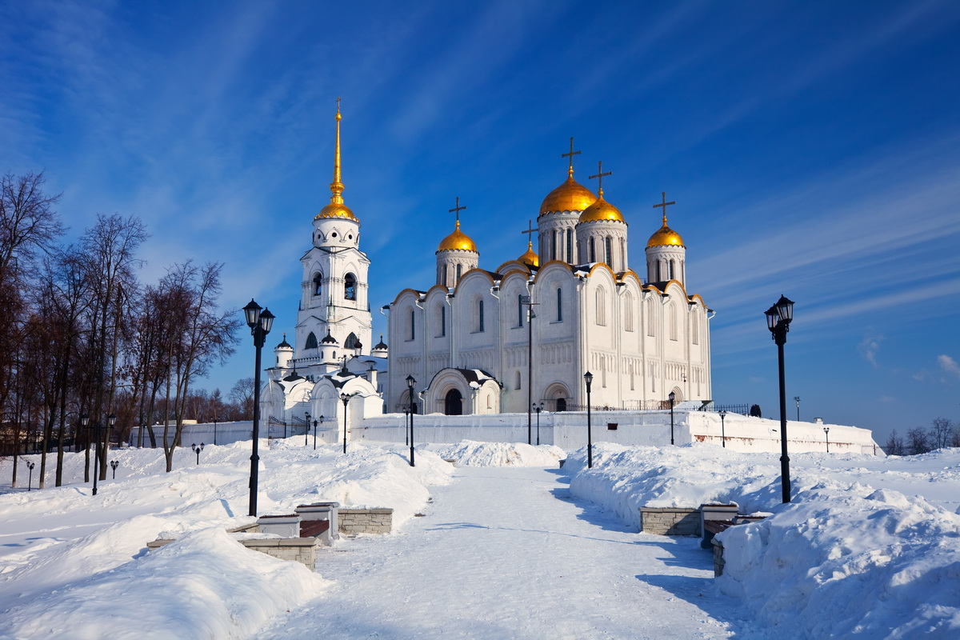

Golden Ring: Sergiev Posad, Vladimir, Suzdal, Kostroma, Yaroslavl, Rostov Veliky 3 days / 2 nights

Itinerary
DAY 1
Departure from Moscow to Sergiev Posad. Excursion to the grand complex of the Trinity Lavra of St. Sergius and its cathedrals, the most important spiritual center of the Russian Orthodox Church, and a kind of orthodox Lourdes thanks to presence of a miraculous spring inside the monastery. Lunch at a local restaurant and departure to Vladimir. City tour with a stop at the impressive Golden Gate, a sort of triumphal arch and a testimony of the ancient fortifications; a visit of the architectural jewels of the XII-XIII centuries: the Dormition Cathedral (Assumption Cathedral), the Cathedral of St. Demetrius, the Cathedral of the Nativity Monastery; a visit to the Museum of Crystal. Transfer to Suzdal and accommodation at the hotel.

DAY 2
Excursion to Suzdal :the visit to this town-museum focuses on its major symbols starting from the XI-XV centuries; the Kremlin, the Museum of Wooden Masterpieces, an open air museum of great ethno-anthropological importance of the XVIII-XIX centuries. In winter the visit to the Museum is replaced by an excursion to the Monastery of Saint Euthymius. Departure to Kostroma, arrival and lunch. City excursion at 4 p.m.: a visit to the Ipatiev Monastery (Hypatian Monastery), the most important artistic monument founded between the XIII and XIV centuries and its interior; a visit to the Trinity Cathedral. Departure to Yaroslavl, one of the most ancient towns of the Golden Ring, founded in 1010, full of churches, monasteries, and beautiful buildings in Baroque and Neoclassical styles. Its old town is a part of the UNESCO World Cultural Heritage. Arrival in Yaroslavl and accommodation at the hotel.

DAY 3
Excursion to Yaroslavl: visit to the Monastery of the Transfiguration of the Savior, one of the most important monuments of the XII century, the Church of Elijah the Prophet, XVII century (in winter the visit to the church is replaced by the Museum of Icons). Departure for Velikiy Rostov, lunch. City excursion starts from the Kremlin, dating from the XVII century and no doubt the most beautiful of the region, and continues with a visit to the museum where you can admire the rare and valuable collection of icons, paintings and miniatures in enamel by local artists. Departure to Moscow.

Prices
Prices per person, based on minimum 2 people sharing a double room. The prices vary depending on group size, rates for individual travelers are available on request. The prices include tax.

2017/2018 season rates:

№ = number of person / Single Supplement (min 2 pax.): €95

Included:
- Accommodation in 3*or 4* hotels, 2 nights, DBL/twin room
- Meals: full board
- Transport: coach, car or minibus, air conditioned
- Excursions and entry tickets as per itinerary
- Private English-speaking guide for all the included excursions as per itinerary
- Visa support/tourist invitation

Not Included:
- Full visa service
- International airfare (included on request)
- Optional tours and services
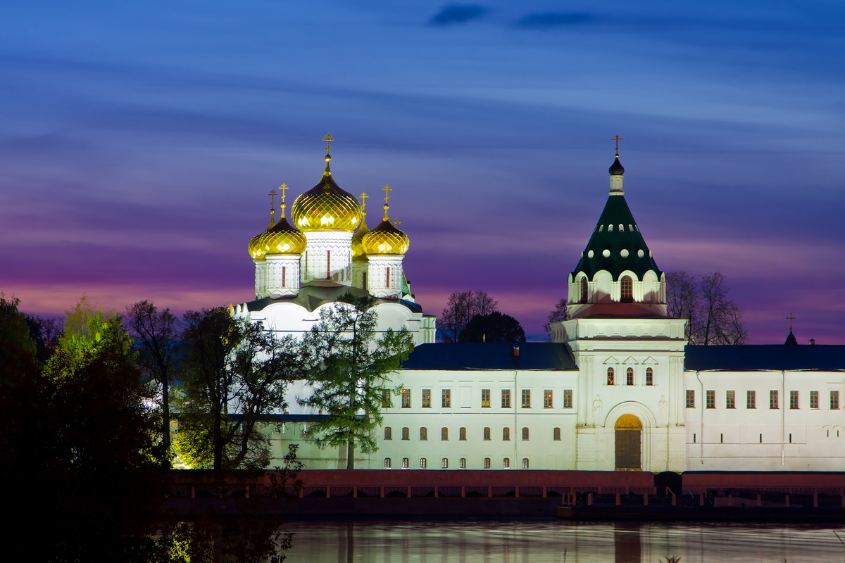

Golden Ring: Vladimir, Suzdal, Kostroma, Yaroslavl, Rostov Veliky 4 days / 3 nights

Itinerary
DAY 1
Departure from Moscow to Vladimir. lunch at the restaurant. Vladimir was founded in 990 by Vladimir the Great, it is situated 180 km north-east of Moscow. The history of this town, built as a fortress on the Klyazma River, dates from around the XII century. When Vladimir became the capital of the Rostov-Suzdal principality, it was progressively enlarged and embellished by splendid monuments, palaces and monasteries. The city tour includes a stop at the impressive Golden Gate, a sort of triumphal arch and a testimony of the ancient fortifications; a visit to the architectural jewels of the XII-XIII century: the Dormition Cathedral (the Assumption Cathedral) and the Cathedral of St. Demetrius, the Cathedral of the Nativity Monastery; a visit to the Museum of Crystal. Transfer to Suzdal, accommodation at the hotel, dinner.

DAY 2
Breakfast at the hotel, excursion to Suzdal. Suzdal, an ancient town located 26 km from Vladimir, is an important center of religious tourism par excellence, and is an UNESCO World Heritage Site with its countless monasteries, churches and historical monuments. Its original appearance was very well preserved compared to the other centers of Russia’s Golden Ring. The visit to this town-museum focuses on its major symbols starting from the XI-XV centuries: the Kremlin, the Cathedral of the Nativity, the Museum of Wooden Masterpieces, an open air museum of great ethno-anthropological importance from the XVIII-XIX centuries. In winter the visit to the Museum is replaced by an excursion to the Monastery of Saint Euthymius. After lunch at the restaurant, departure to Kostroma, arriving in the evening, hotel accommodation, dinner and overnight. Kostroma was founded in the XII century, apart from its monumental beauty, Kostroma is famous for its fascinating geographical location – it is situated on terraces gently descending towards the Volga. The panoramic view from the river at the Ipatiev Monastery is the most famous image of the Golden Ring.

DAY 3
Breakfast at the hotel, city tour of Kostroma: a visit to the Ipatiev Monastery (Hypatian Monastery), the most important artistic monument founded between the XIII and XIV centuries and its interior; a visit to the Trinity Cathedral. Departure to Yaroslavl, one of the most ancient towns of the Golden Ring, founded in 1010, full of churches, monasteries, and beautiful buildings in Baroque and Neoclassical styles. This ancient town is a part of the UNESCO World Cultural Heritage. Lunch at a restaurant, a visit to the Monastery of the Transfiguration of the Savior, one of the most important monuments of the XII century, the Church of Elijah the Prophet, XVII century (in winter visit to the church is replaced by the Museum of Icons). Accommodation at the hotel, dinner and overnight.

DAY 4
Breakfast at the hotel, departure to Rostov Velikij. ‘Rostov the Great’ literally translated in English, is situated on the beautiful Black Lake. It has ancient origins and it was probably founded by Finno-Ugric people. The city excursion starts from the Kremlin, dating from the XVII century and no doubt the most beautiful of the region, and continues with a visit to the museum where you can admire the rare and valuable collection of icons, paintings and miniatures in enamel by local artists. Departure to Pereslavl-Zalessky, a stop for panoramic photos on the Red Square. Departure for Moscow, with a stop at Red Square.

Prices
Prices per person, based on minimum 2 people sharing a double room. The prices vary depending on group size, rates for individual travelers are available on request. The prices include tax.
2017/2018 season rates:

№ = number of person
Single Supplement (min 2 pax.): €135

Included:
- Accommodation in 3*or 4* hotels, 3 nights, DBL/twin room
- Meals: full board
- Transport: coach, car or minibus, air conditioned
- Excursions and entry tickets as per itinerary
- Private English-speaking guide for all the included excursions as per itinerary
- Visa support/tourist invitation

Not Included:
- Full visa service
- International airfare (included on request)
- Optional tours and services

Fully customizable tours
We offer fully customizable Golden Ring cities, Moscow and St Petersburg tours for group and individual travelers. Feel free to choose the option most suitable to your needs choosing the dates, the accommodation and the services that you prefer: we will provide you with a quote and a custom itinerary matching your request!
travel to Russia, whenever you want Our services are available 365 a year, even on very short notice (min 1 week for tour bookings, min 24h for excursions and transfers) and during Russian public holidays!
Plan your perfect itinerary we offer a wide selection of guided tours in Sergiev Posad, Moscow, St Petersburg and various other Russian cities and popular touristic attractions: our experts can help you craft a custom itinerary including all the places you want to see, with connections by plane, train, boat, bus or private car (transportation options are subject to availability).
Choose from a vast array of accommodation options Select your favorite solution from top quality through to great value accommodations and the full range in between, including recommended 3*, 4* and 5* hotels, serviced and non-serviced apartments.
Complement personalized services guides, personal interpreters, car and coach rental, transfers and much more! Thanks to our wide experience and the support of selected partners we can provide a solution for every need.

